Instructions for Completing the Online Course Evaluation

Student Evaluation of Teaching
- Teaching at Oregon State University is an essential part of each instructor's responsibilities. Your responses to this questionnaire will help instructors identify quality teaching skills and methods or discover ways to improve their courses.
- Please take the time to answer each question individually and add your comments in the text box.
- Instructors will carefully consider your comments. Also, supervisors for each faculty member or instructor will use this information to encourage teaching excellence.
- Results of this form are anonymous and are not tabulated until after grades are posted.
---------------------------------------------------------------------------------------------------------------------------------
1. If entering the evaluation area from Blackboard, begin with step 2. If entering the evaluation area from Student Online Services, skip to step 3.

2. From inside Blackboard, the panel on the left describes the different OSU Services. Choose InfOSU. This will bring you to the Online Services page.
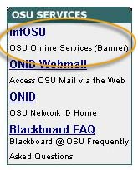
3. From the OSU Homepage, choose Student Online Services.
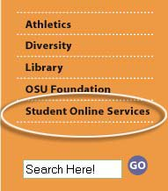

4. Choose Online Services Quick Login.
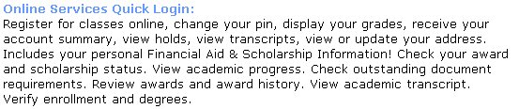

5. Login with your ID and GAP.
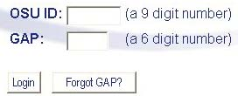

6. At the OSU Online Services page, choose Student Records.
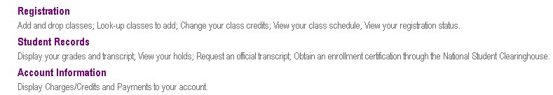

7. Choose Course Evaluation.

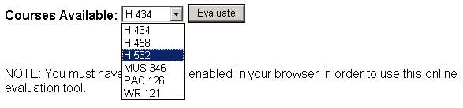
8. Select a course to evaluate from the drop-down menu.
- Click the Evaluate button.

9. Complete each question by selecting the button that corresponds to your answer.
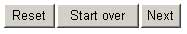
- Click Next to continue to the next set of questions.
- Click Reset to clear the responses on the current page.
- Click Start over to clear all responses and start the evaluation from the beginning.

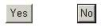
10. After the multiple-choice questions you may choose to make additional comments in the text box. These comments are very helpful to your instructor and are used to improve the course.
- Click No if you have no additional comments. This will submit the evaluation.
- Click Yes to go to the comment form.
  - Enter your additional comments in the appropriate text field.
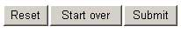
  - Click Reset to clear the responses on the current page.
  - Click Submit to complete the evaluation.

